**If You’re Asked For Your Username/Password**

How to Sign in to:

|  |  |  |
| --- | --- | --- |
| Service | Icon | Login Info |
| Pearson |  | **Username:**  ClassLink login  **Password:**  ClassLink Password |
| Google Classroom |  | **Email:**  **ClasslinkUsername**@stu.chino.k12.ca.us **Password:**  ClassLink Password |
| Office 365 |  | **Email:**  **ClasslinkUsername**@stu.chino.k12.ca.us **Password:**  ClassLink Password |

If you’re having trouble with Google Classroom, please see below:

If you end up on this page, **DO NOT ASK YOUR TEACHER FOR A CLASS CODE**.

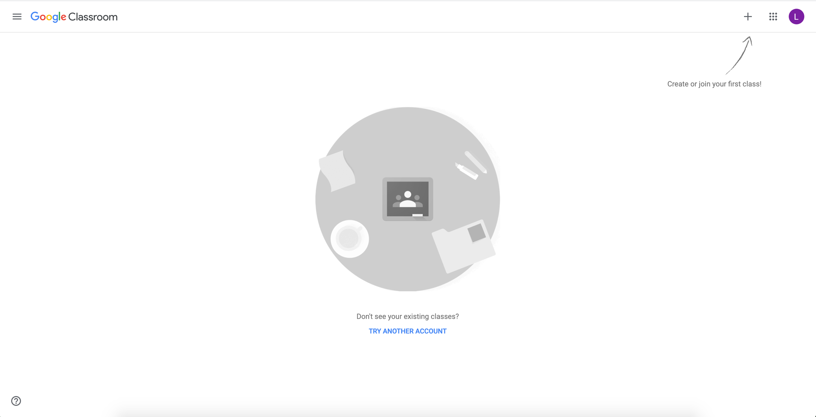

Click the colored circle with the letter inside, and make sure that the account is set for the STUDENT’S EMAIL (it should have an @stu.chino.k12.ca.us ending)

